**Use Cases**

**Jersey Mike’s Subs: Managerial Database**

Taught by: Hong, Dr. Sungchul

Group Members: Colin Jose

  
Towson University

Table of Contents

Loading the current stores in system…………………………3

Adding a Store………………………………………………..5

Loading current employees ……………………………….....7

Adding Employee……………………………………………10

Displaying Weekly Sales…………………………………….13

Loading Current Stores in System

When the user first enters the application he/she arrives at the “Stores” tab. The table shown is empty. As seen in figure 1 below.

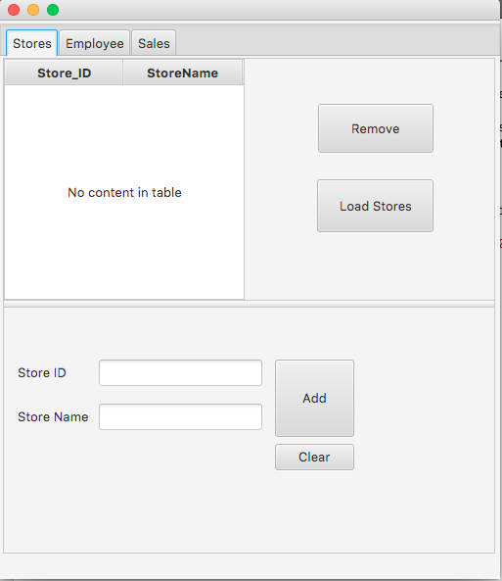

(Figure 1)

In order to populate the table, the user must click the “Load Stores” button that looks like this:



Now the table should be populated as shown below in figure 2.

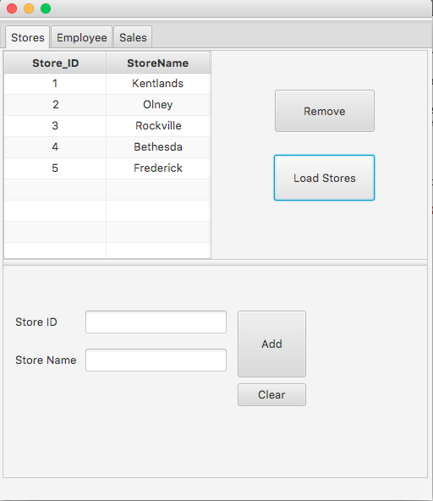

(Figure 2)

Adding a Store

Within the “Stores” tab a user can input a new store into the system. In order to do this the user must first fill out the applicable fields for “Store_ID” and “Store Name”. This can be seen in figure 3 below.

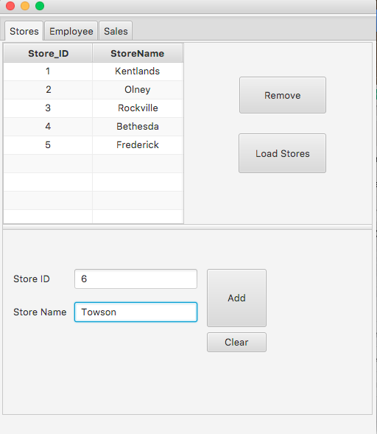

(Figure 3)

After fields are completed the user must click the “Add” button that looks like this:

In order to see your new addition the user must then click the first row of the table and then repeatedly click the “Remove” button that looks like this:



And then reload the table by pressing the “Load Stores” button that looks like this:



Loading Current Employees

Within the “Employees” tab the user will see text fields and an empty table for where employee information should be stored. Upon deployment of the application the table is empty. This can be seen below in figure 4.

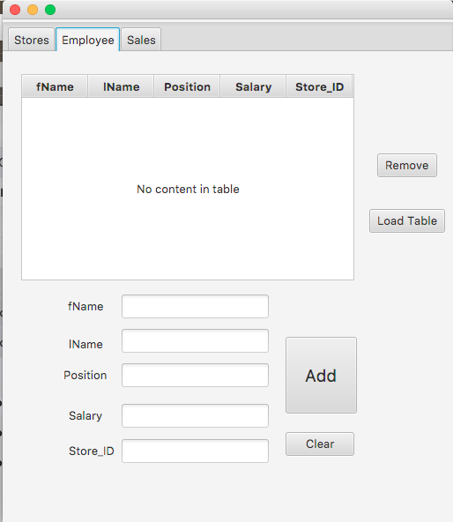

(Figure 4)

In order to populate the table with the current employees within the “Employee” table, the user must click the “Load Table” button that looks like this:



After the button has been pressed the populated table should appear as seen below in figure 5.

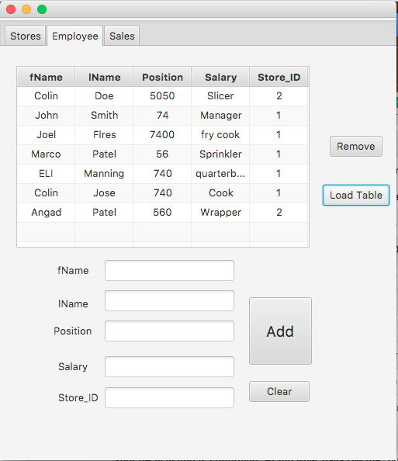

(Figure 5)

Adding an Employee

Within the “Employee” tab a user can input a new employee into the system. In order to do this, the user must first fill out the applicable fields for “fName”, “lName”, “Position”, “Salary”, “Store_ID”. This can be seen in figure 6 below.

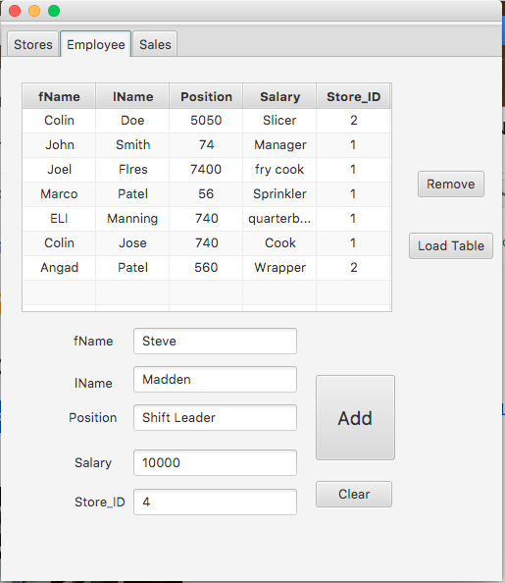

(Figure 6)

Once all fields are filled the user must click the “Add” button that looks like this:

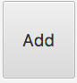

After the “Add” button has been pressed in order to see your new employee the user must click the top row of the table and repeatedly press the “Remove” button until the table is cleared.



Once the table is cleared the user must reload the table to the current state including the addition by clicking the “Load Table” button.



In figure 7 below you can see the addition of “Steve Madden” in the resulting table.

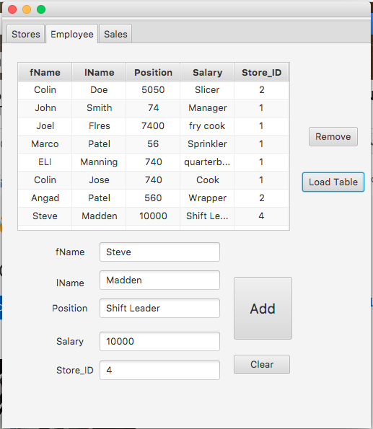

(Figure 7)

Displaying Weekly Sales

Within the “Sales” tab a user can view the amount of sales per week done by each store. When the user first goes to this tab, he/she is presented with an empty table as seen below in figure 8.

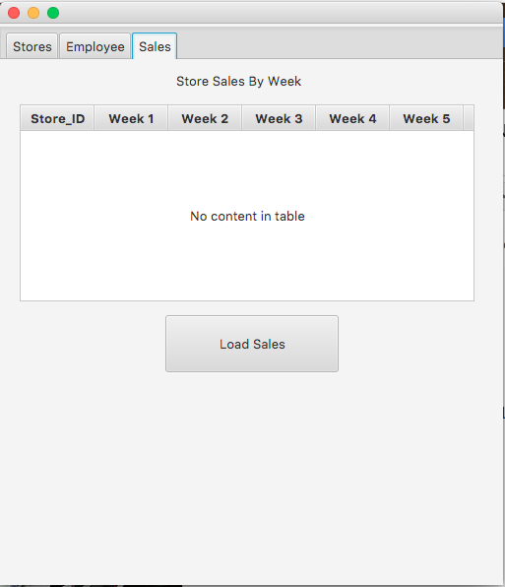

(Figure 8)

In order to populate the table and see current sales numbers, the user must press the “Load Sales” button. That looks like this:



After the button has been pressed the user will be presented with the current sales numbers for all the stores, broken down by week. As seen below in figure 9.

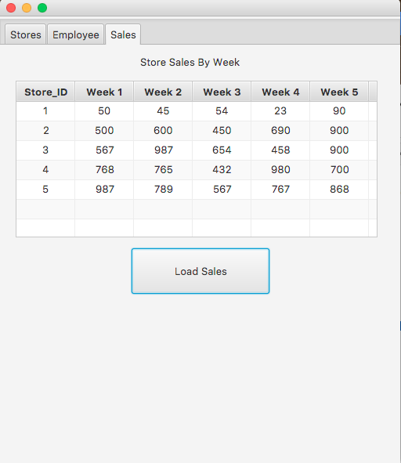

(Figure 9)